**Antimicrobial activity of** ***cis*-[Ru(bpy)2(L)(L’)]n+ complexes, where L=4-(4-chlorobenzoyl)pyridine or 4-(benzoyl)pyridine and L’= Cl- or CO.**

Authors: Aurideia P. de Sousaa, Javier Ellenab, Ana C. S. Gondima, Eduardo H. S. Sousa,a Mayron A. de Vasconcelosc,e, Edson H. Teixeirac, Peter C. Fordf, Alda K. M. Holandaa*

Affiliations:

a. Departamento de Química Orgânica e Inorgânica, Universidade Federal do Ceará Cx. Postal 12200, Campus do Pici s/n, CEP 60440-900, Fortaleza - CE, Brazil

Fax: +55 85 33669978

b. Instituto de Física de São Carlos-USP, Cx. Postal 780, CEP 13560-970, São Carlos - SP, Brazil

c. Laboratório Integrado de Biomoléculas, Departamento de Patologia e Medicina Legal, Universidade Federal do Ceará, CEP 60430-270, Fortaleza - CE, Brazil.

d. Department of Chemistry and Biochemistry, University of California, Santa Barbara, CA 93106-9510, USA

e. Departamento de Ciências Biológicas, Faculdade de Ciências Exatas e Naturais, Universidade do Estado do Rio Grande do Norte, CEP 59625-620, Mossoró -RN, Brazil

*Corresponding author: aldakarine@dqoi.ufc.br



**Fig. S1.** Infrared spectra of complexes *cis*-[Ru(bpy)2(clbzpy)(Cl)](PF6)(black line) and *cis*-[Ru(bpy)2Cl2] (red line).

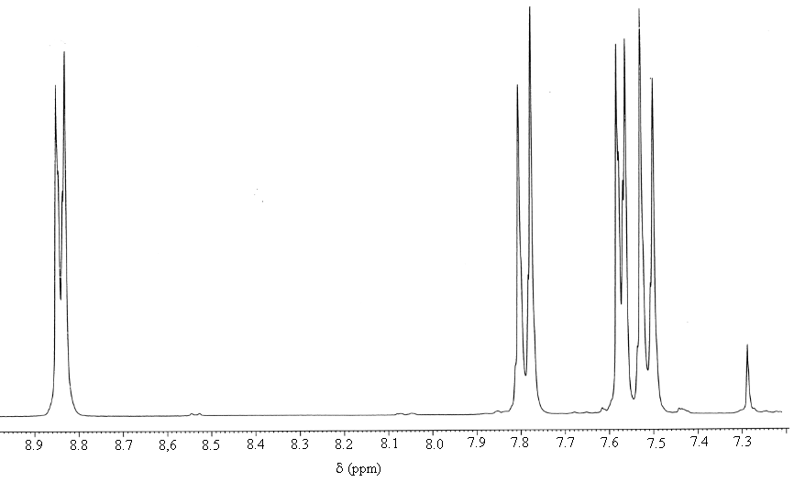

**Fig. S2.** 1H NMR spectrum of 4-(4-chlorobenzoyl)pyridinein DMSO-d6/D2O (5/95) solution



**Fig. S3.** Electronic spectrum of the *cis*-[Ru(bpy)2(clbzpy)(Cl)](PF6) complex in DMSO/H2O (5/95) solution (5.6x10-5 M)



**Fig. S4.** Electronic spectra of the ligand 4-(4-chlorobenzoyl)pyridine in DMSO/H2O (5/95) solution



**Fig. S5.** Quantum yield measurement for 4-4-clbzpy labilization upon 453 nm photolysis of *cis*-[Ru(bpy)2(clbzpy)(Cl)](PF6) in ambient temperature DMSO/ H20 (5/95) solution. This is a plot of the incremental quantum yields for absorbance changes at 460 nm. Extrapolation to t = 0 gives the quantum yield 0.129 corrected for inner filter effects.



**Fig. S6.** Electronic spectra for excluded samples upon treatment onto a biospin column P30. Black spectrum for sample A (*cis*-[Ru(bpy)2(clbzpy)(Cl)](PF6) complex +DNA +light, λirr.=453 nm) and blue spectrum for sample B (*cis*-[Ru(bpy)2(clbzpy)(Cl)](PF6) complex +light, λirr.=453 nm)